THE PERSON OF CHRIST
By Ray Losey, MAR

“Jesus asked, who do men say that I am?” (Matthew 16:15)

WHAT MEN SAY ABOUT JESUS CHRIST:

A Created Being; A mighty god -- Jesus was created a mighty being by God, but is not co-eternal nor co-equal in essence with the Father (Ariaus and Jehovah Witnesses).

A Man Lifted to Deity -- The man Jesus obtained a divine nature as a result of perfect obedience to the law of God. Though Jesus became divine he is not fully divine (Socinian).

A Good Ethical Teacher -- Jesus was a good man, whose ethical teaching ought to be followed. He meant well, but he was not God (Unitarians, Jesus Seminar and Deist).

A Prophet of God -- Jesus was a sinless man and only one God’s many prophets. He survived crucifixion and later ascended into heaven (Islam).

Fully Divine, Not Fully Human -- Jesus has only one nature: a divine nature. He possessed a body but His body was not of the same substance as ours. He was almost ghost like (Apollanarian /Eutychian, Monotheletist).

Had Two Natures (divine and human) and Was Two Persons (a divine person and a human person). He also possessed two minds and two wills (Nestorian).
A mere Man, Christ is an Abstract Idea -- The Christ is the idea of ethical perfection. The Christ idea (invented by the early church) gives humanity the perfect ethical model to following in life (Immanuel Kant).
A Mere Man who Possessed a Supreme God Consciousness -- Jesus came to possess a perfect and unbroken sense of union with the divine. He fully realized the destiny of man in his character of sinless perfection. He was different in that he was only more conscious or aware of the divine within himself. A divine consciousness that is available to each one of us if we just reach out in faith for it (Fredrich Schleirmacher and The Modern Theological View).
“You are the Christ, the Son of the living God” (Peter).

What does the Scripture say about Jesus Christ?

A SEARCH FOR THE TRUE BIBLICAL JESUS

CHRIST’S DIVINITY -- HE IS GOD!

His Full Name: Lord Jesus Christ -- used 58x in N.T.

LORD – “Kurios” Supreme Authority (Philippians 2:11)

JESUS – “Ιησοs” Salvation (Matthew 1:21)


CHRIST – “Χριστοs” Messiah, Anointed One; (Isaiah 61:1; Psalm 2:2; Psalm 22; Daniel 9:25,26; John 1:41; 4:25). Anointed as a Prophet, Priest (Leviticus 4:3) and King i.e.: Saul (1 Samuel 12:3; 26:11); David (2 Samuel 22:51; Psalm 18:50); Cyrus (Isaiah 45:1)
Wnmu

He Possesses The Old Testament Names Of God:

- Immanuel – God with us (Isaiah 7:14 / Mt. 1:23)

- Adonia – Lord: Sovereign Master “Used as a proper name for God only”

"The LORD says to my Lord... If David then calls him 'Lord', how is he his son?"
(Psalms 110:1 / Mt. 22:42-45)


The Christ is both
the son of David,
and
the Lord "Adonia"

- Yahweh -- LORD,

“I Am who I Am”, “I Am the self-existing One”
(Ex. 3:14 / Jn. 8:58; 18:5-6)

"Whoever will call on the name of the LORD (Kurios) will be saved"
(Rom. 10:9-10,13 quoting Joel 2:32)

Paul quotes the Septuagint, the Greek translation of the Hebrew Old Testament.

"Kurios" is used here for "Yahweh" -- Kurios is used throughout the entire Septuagint
for Yahweh.

"Whoever will call on the name of the LORD (Yahweh) will be saved"
(Joel 2:32)

Our English word LORD is a translation of the Greek word Kurios which is a translation of the Hebrew word Yahweh.

JESUS CHRIST IS: LORD, Kurios, Yahweh

- Jehovah -- The name is a combination of the names:

Consonants “Yahweh” Y h w h (LORD)
+
Vowels of “Adonia” a o ia (Lord)

JESUS WHO IS CALLED THE CHRIST IS

Immanuel, God
LORD, Kurios, Yahweh
Lord, Adonia

LORD/Lord, Jehovah

He Possesses The Five Unique And Essential Attributes Of Deity:

These are attributes, which are true of God alone.

# 1 Eternality -- Defined: God is eternal. He has no beginning and no end.
Before there was a beginning there was God (Genesis 1:1).

HUMANITY DIVINITY

Born in "His going forth
Bethlehem are from long ago"

Micah 5:2

A child He will be called...
will be born Eternal Father

Isaiah 9:6

Jesus was Before Abraham
Thirty years old was I AM

John 8:58

The LORD says, Jesus is called the
I am the 'α and the ω'
'α and the ω' first and the last

Isaiah 44:6 Rev. 1:8,18; 21:6

# 2 Immutability -- Defined: God is always the same. He never changes.

“I, the LORD do not change” (Malachi 3:6)

There is “no variation or shifting shadow” (James 1:17)

God is “the same yesterday, today, and forever” (Psalm 102:26-27)
The author of Hebrews applies this to Jesus in 1:10-11, 13:8.

# 3 Omnipresence -- Defined: God is everywhere. He is present everywhere.
There is no place that God is not present.

“Where can I go from your presence?” (Psalm 139:7-10)
Implied answer is nowhere.

Jesus said to His disciples, “I am with you always” (Matthew. 28:19-20)

Jesus promised that “when two or more are gathered I am there” (Matthew 18:20)

# 4 Omnipotence -- Defined: God is all-powerful. He is the most powerful.

"In the beginning God created the heaven and the earth” (Genesis 1:1)

It is said that by “God’s power the mountains were formed” (Psalms 65:6)

Who can create the universe but God? If Jesus created it then He is God.

“Fear God, and give Him glory, because the hour of His judgment has come; worship Him who made the heaven and the earth and sea and springs of waters” (Rev. 14:7)

It is said of Jesus that, "By Him all things were created, both in the heavens
and on the earth (Colossians 1:16; John 1:3)

He made the world and the plans as well (Hebrews 1:10)

The Lord declares, “I am God Almighty” in Genesis 17:1.
Jesus is called "Almighty God" in Isaiah 9:6, and is called "the Almighty"
(compare Rev 1:8 and 19:6).

# 5 Omniscience -- Defined: God is all-knowing. He knows everything. He knows
all that there is to know.

His understanding has no limit (Psalm 147:5)

“For God is greater than our hearts, and he knows everything” (1 John 3:20)

“Nothing in all creation is hidden from God's sight. Everything is uncovered and laid bare before the eyes of him to whom we must give account” (Hebrews 4:13)

It is said of Jesus that, “in Him are hidden all the treasures of wisdom and knowledge (Colossians 2:3)
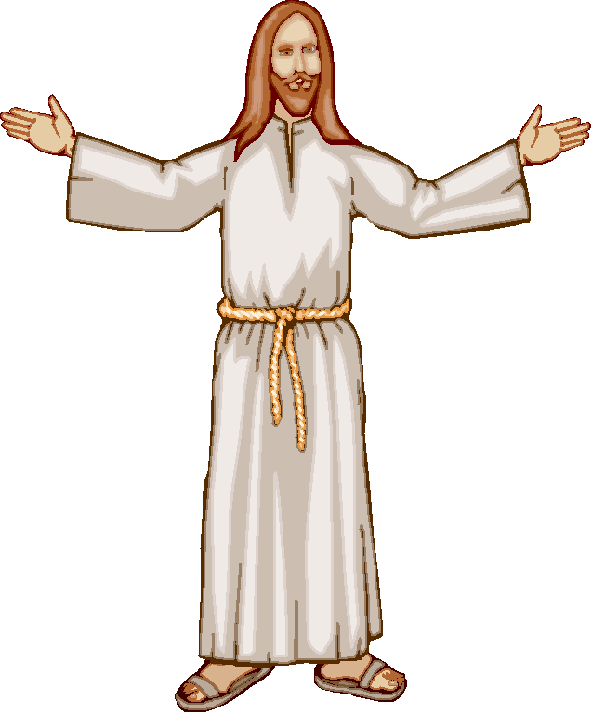

He Made Some Unique Claims Of Deity:

- The Right To Receive Human Worship – Creatures of God bowed down and worshipped Him and He did not refuse their worship: Demons (Mark 5:6); A healed blind man (John. 9:35-36); His disciples (Matthew. 28:9,17); Angels (Hebrews 1:5-6); The four living creatures and the twenty four elders (Revelation 5:8-14).

There is only one God and only He is to be worshipped. “Fear the LORD your God, serve him only” (Deut 6:13; Exodus 20:3-5). Jesus knows this. He said Himself that we are to, “Worship the Lord your God, and serve him only” (Matthew 4:8-10). Nevertheless, He accepted worship that only belongs to God.
The LORD says that He will not give us glory to anyone (Isaiah 42:8). Nevertheless Jesus prays to the Father, “glorify me in your presence with the glory I had with you before the world began” (John 17:5), And says to the Father, “I want those you have given me to be with me where I am, and to see my glory, the glory you have given me” (17:24). Jesus desired to possess the same glory that belongs to God alone.

Contrast: Cornelius worshipped Peter, and Peter refused to accept it (Acts 10:25-26).

People of Lystra worshipped Paul and Silas. They tore their cloths in horror and refused to accept their worship (Acts 14:11-15).

John worshipped the angel that gave the revelation. The angel said to worship God (Revelation 19:10; 22:8-9).

People of Jerusalem worshipped Herod as a god. He accepted their worship and was promptly eaten by worms (Acts 12:20-23).

- The Power To Forgive Sin -- Jesus said to the paralytic, "Son, your sins are forgiven". The teachers of the law correctly understood that only God could forgive sins, "who can forgive sins but God alone?" (Mark 2:5-11; Luke 7:48-50)

- To Be Without Sin -- "Which one of you convicts Me of sin?" (John 8:46) No one!

- His Blood Was Shed For Others -- "for this is My blood of the covenant, which is poured out for many for forgiveness of sins" (Matthew 26:28)

- He Would Judge The World -- “Not everyone who says to me, 'Lord, Lord,' will enter the kingdom of heaven…” (Matthew 7:21-23); “When the Son of Man comes in his glory, and all the angels with him, he will sit on his throne in heavenly glory. All the nations will be gathered before him…” (25:31-32)

- Absolute Equality With God -- "My Father is working until now, and I Myself am working" (John 5:17-29); "He who has seen Me has seen the Father" (14:8-9)

- Infinite And Unique Superiority -- "All things have been handed over to Me by My Father; and no one knows the Son except the Father; nor does anyone know the Father except the Son..." (Matthew 11:27; John 10:15); "I am the bread that came down out of heaven... not as the fathers ate and died; he who eats this bread will live forever" (John 6:35,41,50-51,58,62)

- To Be Higher Than All Other Ties -- “He who loves father or mother more than Me is not worthy of Me” (Matthew 10:37; Luke 14:26)

- That His Disciples Obey His Commandments -- "A new commandment I give you..." (John 13:34; 14:15; 15:12,14)

- To Give Eternal Life -- "I give eternal life to them" (John 10:28; 17:2; I John 2:25)
These Claims Prove One of Three Things

JESUS IS EITHER:
Liar – He wanted people to believe he was God, but knew he was not.
Lunatic – He really thought He was God, but was not.
Lord – Jesus is God!


His Deity Is Proclaimed In The Scriptures By Others:
(Direct Statements from Scripture Declaring the Deity of Jesus Christ)

John

- “In the beginning was the Word, and the Word was with God, and the Word was God… And the Word became flesh, and dwelt among us, and we saw His glory, glory as of the only begotten from the Father, full of grace and truth” (John 1:1,14)

- “No one has seen God at any time; the only begotten God who is in the bosom of the
Father, He has explained Him” (John 1:18)

- “…we are in Him who is true, in His Son Jesus Christ. This is the true God and
eternal life” (I John 5:20)

Thomas

- “Thomas answered and said to Him, "My Lord and my God!" (John 20:28)

Paul

- “…looking for the blessed hope and the appearing of the glory of our great God and
Savior, Christ Jesus” (Titus 2:13)

- “…whom is the Christ according to the flesh, who is over all God blessed forever.
Amen” (Romans 9:5)

- “For in Him all the fullness of Deity dwells in bodily form” (Colossians. 2:9)

The Author of Hebrews

- “He is the radiance of His glory and the exact representation of His nature…”
(Hebrews 1:3)

The Father

- “But of the Son He says, "Your throne, O God, is forever and ever…”
(Hebrews 1:8)

SUMMARY

  - He Possesses The Names Of God

  - He Possesses The Attributes Of God

  - He Made Claims That Only God Would Make

  - He Is Claimed To Be God By His Apostles

  - He Is Claimed To Be God By The Father

Who do you claim Him to be?

CHRIST’S HUMANITY -- AN ADDED DIMENSION (1 + 1 = 2)

He Experienced Human Birth and Growth

- “And she gave birth to her firstborn son; and she wrapped Him in cloths, and laid Him in a manger… you will find a baby wrapped in cloths and lying in a manger” (Luke 2:7,12)

- “The Child continued to grow and become strong, increasing in wisdom…” (2:40-52)

He Possessed a Human Body During His Life on Earth

- “…since the children share in flesh and blood, He Himself likewise also partook of
the same…” (Hebrews 2:14)

- “A body you have prepared for Me…” (Hebrews 10:5)

- “Jesus, being wearied from His journey…” John 4:6

He Possesses a Human Body after His Resurrection

- “See My hands and My feet, that it is I Myself; touch Me and see, for a spirit does not
have flesh and bones as you see that I have” (Luke 24:39)

- “This Jesus, who has been taken up from you into heaven, will come in just the same
way as you have watched Him go into heaven” (Acts 1:11) Jesus return bodily into heaven and will return with the same body.

- “For in Him all the fullness of Deity dwells in bodily form” (Colossians. 2:9). He
presently possesses a human body.

He Appears to be a Human Being by Others

- “He was in the world… and the world did not know Him” (John 1:10). The world did
not know that He was God. He looked like an ordinary man.

- “You, being a Jew” (John 4:9). Jesus appeared to be a Jewish person to the Samaritan
women.

- “Who do people say that the Son of Man is?” And they said, "Some say John the
Baptist; and others, Elijah; but still others, Jeremiah, or one of the prophets”
(Matthew 16:13-14). He is a man. None say He is an angel or a god or God.

His Humanity is Proclaimed by The Apostle Paul

- “…by the grace of the one Man, Jesus Christ” (Romans 5:15). He is contrasted with
the man, Adam.

- “For since by a man (Adam) came death, by a man (Jesus) also came the resurrection
of the dead” (I Corinthians 15:21)

- “For there is one God, and one mediator also between God and men, the man Christ
Jesus” (I Timothy 2:5)
Jesus Is One Person Possessing Two Natures Divine And Human
He Is Fully Divine and Fully Human
He Is The God/Man

QUESTION? Why is it necessary for the Savior to be both God and Man?

He had to be a Man so that He could die, for God cannot die. He had to be God to qualify as Savior of the world. Only the Infinite could pay the price for infinite sin.

CHRIST’S INCARNATION -- WHY HE CAME TO EARTH
DEFINITION: “carne” – “flesh; “in fleshed”; the infleshing of God”. The incarnation is the divine act in which the second person of the Godhead was embodied in human nature, flesh and form. “The Word became flesh…” (John 1:18)

He Came to Reveal the Invisible God

- “No one has seen God at any time; the only begotten God who is in the bosom of the
Father, He has explained Him” (John 1:18)

- “God, after He spoke long ago to the fathers in the prophets in many portions and in
many ways, in these last days has spoken to us in His Son” (Hebrews 1:1-2)

He Came to Provide an Offering for Sin

- “He Himself bore our sins in His body on the cross, so that we might die to sin and
live to righteousness; for by His wounds you were healed’ (I Peter 2:24)

- “This is My blood of the covenant, which is poured out for many for forgiveness of
sins” (Matthew26:28)

He Came to “Render Inoperative” the Power of Satan

- “…in flesh and blood, He Himself likewise also partook of the same, that through death He might render powerless him who had the power of death, that is, the devil” (Hebrews 2:14)

He Came to Deliver Men from the Fear Of Death

- “…and might free those who through fear of death were subject to slavery all their lives” (Hebrews 2:15)

He Came to Give the Redeemed a High Priest

- “He had to be made like His brethren in all things, so that He might become a merciful and faithful high priest in things pertaining to God, to make propitiation for the sins of the people” (Hebrews 2:17)

- “For we do not have a high priest who cannot sympathize with our weaknesses, but One who has been tempted in all things as we are, yet without sin” (Hebrews 4:15)

He came to Show Believers How to Live

- the one who says he abides in Him ought himself to walk in the same manner as He walked” (I John 2:6)

- “Christ also suffered for you, leaving you an example for you to follow in His steps” (I Peter 2:21)

He Came to Fulfill the Davidic Covenant

- “He will be great and will be called the Son of the Most High; and the Lord God will give Him the throne of His father David; 33 and He will reign over the house of Jacob forever, and His kingdom will have no end” (Luke 1:32-33)

- “The record of the genealogy of Jesus the Messiah, the son of David…” (Matthew 1:1)

He Came to Make us Rich

“For you know the grace of our Lord Jesus Christ, that though He was rich, yet for your sake He became poor, so that you through His poverty might become rich (II Corinthians 8:9)

An Erroneous View Concerning the Incarnation -- The Kenosis Error

DEFINITION: The Kenosis Error is the teaching that Christ at His incarnation emptied Himself of His divinity or that Christ ceased to possess the attributes of deity. Jesus ceased being God.
Response:

Being truly God, He could not cease to be God. By the very definition God is who He is and God cannot change (James 1:17). God cannot be less than God at anytime and still be God.

He voluntarily gave up the independent use of His attributes of Deity. Some theologians suggest that at times Jesus used His own omni-attributes but only by permission of the Father. He did not use them independently from the Father.

He gave up the use (altogether) of His attributes of Deity. Jesus did not use His omni-attributes at all while here on the earth. He did not set aside His divine nature.

Key Passage -- (Philippians 2:5-8)

“Have this attitude in yourselves which was also in Christ Jesus, who, although He existed in the form of God, did not regard equality with God a thing to be grasped, but emptied Himself, taking the form of a bond-servant, and being made in the likeness of men. Being found in appearance as a man, He humbled Himself by becoming obedient to the point of death, even death on a cross”

Key Words or Phrases:

- “He (Christ Jesus) existed in the form of God…” -- He was the very form (morphe),
the very essence of God. His inner essence and essential nature is identical to God’s. A morphe type of wood is a solid piece of wood. I.e.: pure mahogany, not a composite. Jesus is solidly God. He is through and through, God.

- “He did not regard equality with God a thing to be grasped…” -- Being equal to God means He was identical to God. Although He was equal with God, equality was something He could set aside or appear to be without. He was never less than equal with God, but it was not something He would cling to under all circumstances.

- “He emptied Himself…” -- The main verb “emptied” (ekenosen) means “to pour out”. Something was poured out, emptied, laid aside. He emptied Himself by…

- “taking the form of a bond-servant…” -- He took the form (morpe) of a bondservant. He added to His divine nature the nature of a slave.

- “being made in the likeness of man…” – Being made in a point in time, He became like of a man. He did not always exist as a man but became one. “likeness” (homoioma) is that which resembles something but is in some way different. He resembled a man, but was different in that He was more than just a man.

- “being found (fashioned) in appearance as a man…” -- He was fashioned (skema) to appear as a man. “fashion” (skema) is that which may change without affecting the form (morpe). A (skema) type of wood is a veneered piece of wood. A thin layer of wood laid over another type of wood. Jesus became a man. He was and is still a man. To the world and on the outside he looked or appeared like a man, but He was something more than just a man.

- “He humbled Himself…” -- By adding the nature of a human servant, He demonstrated humility. The extent of His humility is demonstrated…“by becoming obedient to the point of death, even death on a cross”. He humbly set aside (did without) the revealing of His glorious divine nature. His humbling was astonishingly to the point of death, but more astonishingly it extended to even being tortured to death.

A Paraphrase of Philippians 2:5-8

“Christ Jesus existed in the very form or essence of God, and He was by nature equal with God. However, He did not hold on to His equality with God, but subtracted Himself by adding to Himself a servant nature and a human nature. He humbly set aside the revelation of His glorious divine nature demonstrated amazingly by His perfect obedience of enduring a torturous and humiliating death of crucifixion”.
THE KENOSIS WAS SUBTRACTION BY ADDTION

Christ Jesus emptied Himself of self by taking on servanthood and humanity. He imposed a volunteer self-limitation of the full exercise of His divine power and attributes in order to experience everything it means to be human. He did not lay aside any attribute, but temporarily subtracted the use of His omni-attributes. He did not cease to possess any divine attribute, but voluntarily limited the use of His divine power. He appeared not to be God when He added the role of a Servant and the nature of humanity.
HE DID NOT ACT LIKE GOD

The Lord became a slave and by doing so He did not act like the Lord God, since He does not serve anybody (Neither does one person of the Godhead serve another). However, when the Lord came down, He came as a Servant to the Father, to do His will, by offering Himself as a sacrifice to redeem humanity (Mark 10:45) and to teach us about God (John 1:18). As He obeyed the Father He did not act like God. In His death He did not act like God, because God being the very essence of life cannot die.
HE DID NOT LOOK LIKE GOD

The Lord became a man (Jesus) and by doing so He no longer looked like God, but looked and appeared like a man. God is a spirit, and does not have flesh and bones. All of the glories of God were hidden behind His humanity. On the Mount of Transfiguration the veil of His humanity was removed and His divine glory was shown, so that He looked like God and not a man (Matthew 17:1-8). When He comes in glory He will appear like God and a man (Revelation).

QUESTION? If Jesus did not use His omni-attributes at all, then how did He perform miracles acts? I.e.: healings, stilling the storm, walk on water, the resurrection, and so forth.

ANSWER: He accomplished them through the power of the Holy Spirit.


SUMMARY

The Incarnation was not a casting off His deity but merely union with a human body. It was a resigning the volunteer use of His omni-attributes, an acceptance of dependence on the Father, a subjection of Himself to the Holy Spirit, and a voluntary acceptance of His temporary suffering, culminated by His death, in order that He may redeem and save humanity.

CHRIST’S VIRGIN BIRTH -- HOW HE CAME TO EARTH
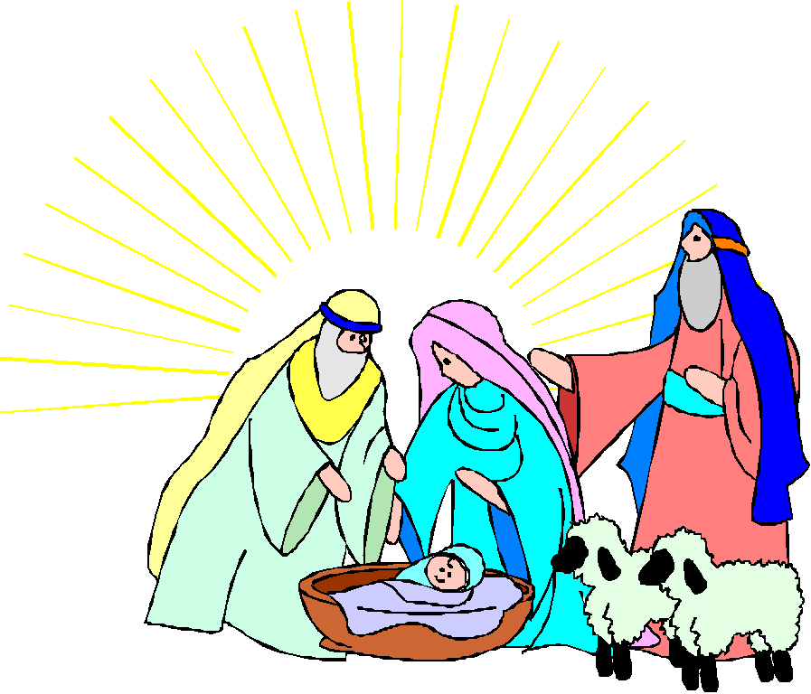

The Announcement of His Birth

“Therefore the Lord Himself will give you a sign: Behold, a virgin will be with child and bear a son, and she will call His name Immanuel” (Isaiah 7:14-15), “…which translated means ‘God with us’ (Matthew 1:22-23)

His Birth is Described as Something Extraordinary in the Old Testament

His birth is described as a child born of a “Ha Almah” literally the Hebrew word for “a young women”. Though “Ha Almah” is the most appropriate word available in Hebrew, the Messiah’s birth has to be described as an extraordinary miracle of generation in order for the sign of a virgin to have any meaning. His Birth had to be a great miracle to the house of David If it simply means that a young women will have a child then it is no great miracle. For a woman, even a young woman to have a child is no miracle. It happens every day. The sign of virgin is meaningless if it just means a young woman. It means something more and something usual.

The Hebrew word “Ha Almah” was the most appropriate word available. There is a duel fulfillment given in the sign, a near one, a young woman in Isaiah’s day, and a far one, a virgin in New Testament times. “Immanuel” cannot refer to a child of Isaiah or Ahaz only (see Isaiah 8:3).

Septuagint translates “Ha Almah” with “parthenos” meaning “virgin” – (Septuagint is the LXX: 70 men in 70 days who translated the O.T. Hebrew into Greek in Alexander, Egypt sometime between 150 to 200 BC).

The context speaks of the Christ being divine (Isaiah 8:8-10; 9:6-7). “For God is with us”. Messianic passages throughout the O.T., ascribes deity to the coming Messiah, i.e.: eternal Father, Almighty God, etc. The passages describe the Christ doing only things God could do.

His Birth is Proclaimed in the Gospel Accounts as a Virgin Birth

- Matthew 1:16 – Jesus was born by Mary only. Joseph is only referred to as the husband of Mary, not the father of Jesus. In verse 16 the “whom” “ηs” is feminine and singular. The Greek is very specific. The English is vague.

- Matthew 1:22 -- Mary is called in Greek a “parathenos” meaning “virgin”, a women who has had no sexual relations with a man.

- Luke 1:26-35 – Mary is called a virgin twice in verse 27, and Mary calls herself a virgin in verse 34. She literally says that she has “not known a man”. The Biblical way of saying she had not had sexual intercourse.

- Luke 3:23 – Jesus is described as “supposedly the son of Joseph”.

His Virgin Birth Was Necessary, But Why?
M.R. Dehan argued in a book called “The Chemistry of the Blood” that Jesus’ blood was unique, especially created by God. He did not inherit or possess the blood of His father Joseph. The virgin birth was necessary because people inherited sin and the sin nature through the blood of the male. If Jesus had inherited Joseph’s blood He would have also inherited his sin nature.

A Popular But Erroneous View

Jesus had to be born a virgin in order for Him to remain sinless.

Response: It was not necessary for Jesus to be born of a virgin in order to remain sinless.

He would have remain sinless, even if He had not be born of a virgin, simply because He is the Holy One. God becoming human could not corrupt Him.

If it was possible for God to be corrupted by humanity why would He not also been corrupted by Mary and her blood? Are men the only carriers of the sin nature? Do not women possess a sin nature? Yes!

The Scriptures describe Jesus as partaking of the same flesh and blood as all humans partake from their parents. He did not have divine blood. There is no such thing as divine blood. God is a Spirit, and is incorporeal, that is He has no flesh and bone (Luke 24:39; Deut. 16:22). Heb. 2:14-18 He was made like His brethren, the descendents of Abraham, otherwise He could not have become a merciful and faithful high priest, nor become a propitiatory sacrifice, or even be tempted of sin, since God cannot be tempted.

Another Popular But Erroneous View
If Jesus had been born of both Mary and Joseph then, His birth would not have been a miracle, and the miracle was necessary in order for Him to retain His deity. A normal human birth would have produced a man and only a man.

Jesus had to be born of a virgin in order
for Him to retain His deity.

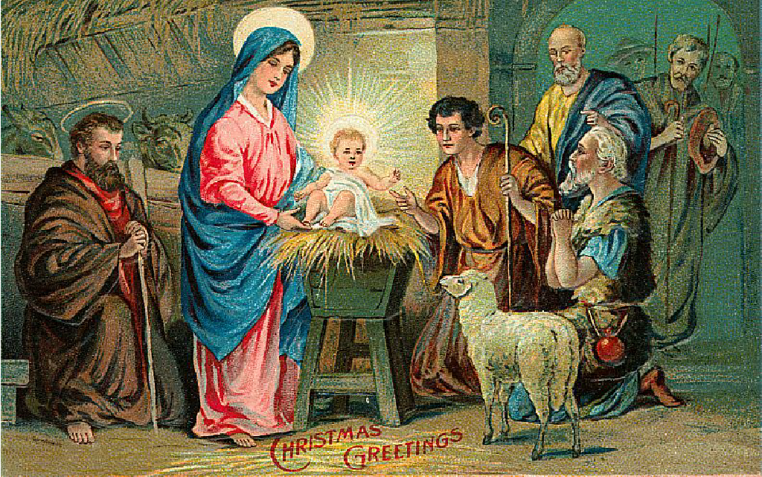

Response: It is a miracle that God could be born through any human, virgin or not. If God so chose, Jesus could have been born of both Mary and Joseph. It still would have remained a miracle for God to become a man. Many deny the incarnation of Jesus simply because they believe it is impossible for God to become a full-fledged man by any means.

A Virtually Unknown But Correct View
The curse stated that no descendant of Coniah would prosper sitting on the throne of David (Jeremiah 22:24, 28; 37:1). Joseph, Jesus’ father, was in that line. If Jesus had been born of Joseph He could not have inherited the throne of David. He was physically disqualified through Solomon’s line from inheriting the throne of David and from being the Messiah.

It was necessary for Jesus to be born of a virgin because of God’s curse on Coniah (Jehoiachin).


Solution: The Virgin Birth. It made it possible for Jesus to inherit the throne of David despite the curse of Coniah for the following reasons:

Mary was of David’s line through Nathan giving Jesus the physical right to inherit the throne (Luke 3:23-38). Jesus was not a physical descendent of Solomon consequently the curse is not dilemma.

Joseph was of David’s line through Solomon giving Jesus the legal right to inherit the throne (Matthew 1:1-17). The Messiah must inherit the throne of a David through Solomon according to II Samuel 12-16 and Acts 2:30.

Nathan - - - - - - - - - - - - - - - - - - - - - - - - - - Mary

Physical Right
David Jesus

Solomon - - - - - - - - - - Coniah (curse) Joseph

Legal Right

Conclusion: Jesus’ physical right to the throne is established through Mary. Jesus’ legal right to the throne is established through Joseph. He was the only one at that time or since who could claim the throne of David. Thus, the absolute necessity of the virgin birth.



Material and outline on “The Person of Christ” is used by permission by Dr. Norman Sellers, National Bible College, Theology III, The Person and Work of Christ, 39-55.

